Artificial neural networks for solution scattering data analysis

D.S. Molodenskiy1, D.I. Svergun1\* and A.G. Kikhney1\*

1 European Molecular Biology Laboratory, Hamburg Outstation, EMBL c/o DESY, Notkestrasse 85, D-22607 Hamburg, Germany

Corresponding authors: [svergun@embl-hamburg.de](mailto:svergun@embl-hamburg.de)

[a.kikhney@embl-hamburg.de](mailto:a.kikhney@embl-hamburg.de)

# Abstract

Small-angle X-ray scattering (SAXS) experiments are widely used for the characterization of biological macromolecules in solution. SAXS patterns contain information on the size and shape of dissolved particles in nanometer resolution. Here we propose a novel method for primary SAXS data analysis based on the application of artificial neural networks. Trained on synthetic SAXS data, the feedforward neural networks are able to reliably predict molecular weight and maximum intraparticle distance (*Dmax*) directly from experimental data. Our method is applicable to data from monodisperse solutions of folded proteins, intrinsically disordered proteins and nucleic acids. The method was rigorously tested against synthetic SAXS data on various angular ranges and levels of noise and demonstrated higher accuracy and better robustness against simulated experimental noise compared to other methods.

# Introduction

Small angle X-ray scattering (SAXS) from biological macromolecules in solution is a powerful tool, providing information on supermolecular structures and dynamics under a wide range of conditions (Feigin et al., 1987; Gräwert and Svergun, 2020; Guinier and Fournet, 1955). Due to relatively soft requirements to sample preparation for SAXS experiments and recent progress in the development of data analysis software (Hopkins et al., 2017; Liu et al., 2012; Manalastas-Cantos et al., 2021), the technique became high throughput and widely available.

SAXS data are obtained by illuminating a dilute, typically monodisperse solution of macromolecules with a monochromatic X-ray beam which results in an isotropic 2D scattering pattern. The 2D pattern can be azimuthally integrated into 1D scattering profile which represents the scattering intensity I(s) as a function of the scattering vector s = 4πsinθ/λ, where θ is the half of the scattering angle between incoming and diffracted beams, and λ is the X-ray wavelength. The “background” scattering from the pure solvent is independently measured and subtracted from the solution scattering. From the background-subtracted scattering profile, one can estimate structural characteristics of the scattering particle: radius of gyration (Rg), maximum intraparticle distance (Dmax), pair-distance distribution function (p(r)), molecular weight (MW). Given these parameters, it is possible to reconstruct the overall shape *ab initio* or obtain a hybrid model employing structural information from the high-resolution methods.

There is a number of well-established methods for the estimation of MW from SAXS data on a relative scale (i.e. not relying on scattering from calibrants). The optimistic estimate of the accuracy of these methods is 10% [Nelly, 2018]. These methods have been developed primarily for globular proteins and their applicability to SAXS data from disordered proteins and nucleic acids is questionable. Here, we explore the applicability of artificial neural networks (NN) to primary SAXS data analysis: estimation of MW and Dmax for data from folded proteins, intrinsically disordered proteins (IDP) and nucleic acids.

Recently, the application of neural networks has experienced a sudden leap in almost all areas of everyday life, due in no small part to the development of deep learning technologies (Schmidhuber, 2015). Massive progress has happened in many biological applications as well, including bioinformatics (Armenteros et al., 2019), a recent breakthrough in *in silico* protein folding by AlphaFold (Senior et al.), and even in the area of SAXS shape reconstruction (He et al., 2020).

Neural networks are excellent tools for supervised learning; the taskof learning a function that maps an input to the desired output based on a training data set. In our case, the input is a vector of experimental intensities I(s) on a relative scale and the output could be a scalar representing an overall geometrical parameter, e.g. the MW or Dmax value. Since obtaining reliably labeled experimental SAXS data in sufficient quantities is challenging, one could compute the scattering from known protein and nucleic acid models for training assuming that the learned function would be applicable to experimental data.

The simulated training set can be augmented: this way, one can easily adjust the area of applicability of e.g. a given NN model and tailor it for the specific objects, instrumentation features or experimental setup. One example from the SAXS area is the robustness of predictions against experimental noise, which is inevitably present in any SAXS data, reduces the information content in experimental SAXS data thus increasing the ambiguity of data interpretation.

We employed several feedforward artificial NNs trained on noise-augmented synthetic SAXS data generated from thousands of experimentally determined models to estimate MW and Dmax from folded proteins, unfolded proteins and nucleic acids. Here we demonstrate that our method has higher accuracy and is less demanding in terms of data quality compared to the well-established methods for folded proteins and nucleic acids. To the best of our knowledge, our method is unique for MW estimation from SAXS data of intrinsically disordered proteins. Our method can reliably estimate the maximum intraparticle distance Dmax directly from the SAXS profile for the above-mentioned macromolecule types.

# Estimation of the MW from SAXS data.

To date, there are several well-established techniques for MW estimation, that could be subdivided into two major categories: concentration-dependent and concentration-independent methods. The former account for the dependence of the forward scattering I(0) on the total number of electrons in the irradiated molecule (and, thus, on MW) and rely on the scattering from calibrants, e.g. water or a protein with known MW (Mylonas and Svergun, 2007) and precise measurement of the sample concentration. The latter methods utilize a single background-subtracted profile on a relative scale and require no additional *a priori* information on sample concentration, partial specific volume and scattering contrast. In circumstances where the protein concentration cannot be accurately measured (e.g. for in-line SEC-SAXS experiments), these methods are necessary to obtain a reliable MW assessment. In the scope of this work, we focus on concentration-independent methods.

**Porod’s method.** The historically first concentration-independent method is the so-called Porod’s method [Porod, G. Die Röntgenkleinwinkelstreuung von dichtgepackten kolloiden Systemen - I. Teil. Kolloid-Zeitschrif 124, 83–114 (1951)]. It is based on the fundamental properties of the Fourier transform known as the Parseval theorem:

, (1)

where s is the scattering vector, I(s) – the intensity of the scattered beam, Δρ – excessive electron density, and Q is the Porod invariant. If we consider the scattering particle to be of homogeneous electron density, the right part of the equation (1) simplifies to:

$Q=2π^{2}{∆ρ}^{2}V$, (2)

and given that intensity in the origin equals I(0) = (Δρ)2V2:

. (3)

The MW is typically estimated as an empirical relation between the volume of the particle and its mass, which e.g. in the case of folded proteins equals MW/V = 0.625 (Petoukhov et al., 2012). Therefore the precise calculation is limited by the three factors: (i) integration in (1) can not be performed due to limitations in real experimental s-range, assuming globular proteins I ~ s-4 power law is usually applied to extrapolate the intensities on higher angles; (ii) integration is affected by the experimental noise and the accuracy of background subtraction; and (iii) the equation (2) implies homogeneity of the scattering particle.

**SAXSMoW method.** The accuracy of the Porod’s method was improved by (Fischer et al., 2010)[ Piiadov, Vassili, et al. "SAXSMoW 2.0: online calculator of the molecular weight of proteins in dilute solution from experimental SAXS data measured on a relative scale." *Protein Science* 28.2 (2019): 454-463.]. In this approach, the authors integrate the Porod invariant in (1) not up to infinity, but up to fixed smax values:

$Q^{'}=\int_{0}^{s_{max}}{s^{2}I\left(s\right)ds}$. (4)

The authors introduce the so-called apparent volume as $V'=2π^{2}I(0)/Q'$ (similarly to (3)), and establish a linear dependence between V and V’:

V = A + BV’ , (5)

where the linear and angular coefficients A and B were determined empirically for different smax values from protein SAXS data. Given the look-up table with A and B values, one can find these coefficients corresponding to the experimental smax and obtain a more accurate prediction for the MW.

**Volume of correlation.** Another approach was developed by (Rambo and Tainer, 2013) and introduces the so-called volume of correlation:

$V_{c}=\frac{I(0)}{\int_{0}^{∞}{sI\left(s\right)ds}}$. (6)

The authors found an empirical dependence between Vcand the molecular weight:

, (7)

where c and k are empirically determined constants via fitting results from theoretical scattering profiles. The authors mentioned ec = 0.1231 and 1/k = 1 for proteins and ec = 0.00934 and 1/k = 0.808 for RNA. Thus, this approach is applicable not only to SAXS data from proteins but to RNA data as well.

**Machine learning methods.** The web server for rapid search of structural neighbours DARA [Kikhney,2016] accepts SAXS data from proteins, nucleic acids or their complexes, finds the closest SAXS profiles precomputed from PDB [ref] models and reports the MW and Dmax of these models. If there is a structural neighbour that fits the experimental data, then these values can be used as the estimates of overall structural parameters.

The size&shape method (Franke et al., 2018) allows for a fast and selective lookup of structural neighbours in a database of SAXS patterns pre-computed from geometrical bodies and protein models from the PDB. This approach enables rapid multiclass shape classification (compact, extended, random-chain etc.) and estimation of Dmax and MW directly from experimental SAXS data from proteins.

**Bayesian assessment of protein molecular weight.** In the recent method (Hajizadeh et al., 2018) the authors calculate an MW using Bayesian inference with the MW calculations from the above-mentioned methods as the evidence. The authors simulated a large test dataset of SAXS profiles, then calculated the MW for each profile using each method to build a probability distribution, that describes the original probability of obtaining a particular calculated MW given the true molecular weight. These probabilities are combined across all the methods, and the most likely molecular weight is thus estimated. The advantage of the method is that it employes all the other methods and provides the most probable MW alongside its credibility interval. The disadvantage is similar to the Shape&Size method - it works only for compact proteins.

# Estimation of the maximum intraparticle distance Dmax from SAXS data.

The classical indirect Fourier transform (IFT) method for an estimate of the Dmax requires the introduction of the pair distance distribution function p(r). The p(r) function represents a histogram of distances between pairs of points in the particle, weighted by the product of their scattering contrasts (Guinier and Fournet, 1955). Mathematically, the p(r) function is closely related to the scattering intensity I(s) via the spherically averaged Fourier transformation (Debye, 1915):

$I\left(s\right)=\int_{0}^{D_{max}}{p(r)\frac{sin⁡(sr)}{sr}dr}$, (8)

$p\left(r\right)=\frac{r}{{2π}^{2}}\int_{0}^{∞}{sI(s)sin(sr)ds}$. (9)

It is implied that p(r > Dmax) = 0. The limited angular range of the experimental data, as well as the presence of experimental noise, make the evaluation of p(r) an ill-posed problem. The method of solving this problem by the IFT has been originally proposed by Glatter (Glatter, 1977), and further enhanced by Svergun (Svergun, 1992) and Hansen (Vestergaard and Hansen, 2006). In the IFT approach, *Dmax* as an input parameter must be provided. The p(r) function is expressed as a sum of analytical functions (e.g. cubic splines). Finally, the classical regularization procedure [Tikhonov] is applied such that the p(r) agrees to experimental data and ensures satisfaction with the imposed constraints. Most commonly the constraint is the smoothness of the p(r), so that termination effects are reduced as much as possible. However, in these approaches, the choice of the final solution remains a subjective criterion left to the discretion of the user.

In the program AUTOGNOM [Petoukhov 2007] (later DATGNOM), multiple runs of the program GNOM (Svergun, 1992) are performed with Dmax values ranging from 2Rg to 4Rg to find the optimum Dmax and p(r) function. Here Rg is the radius of gyration from the Guinier approximation.

# Methods

Training/validation/test sets

In this study, we considered three types of biological macromolecules: folded proteins, intrinsically disordered proteins (IDP) and nucleic acids. To construct a training set we have prepared experimentally determined atomic models of the macromolecules. Each model was examined for connectivity, models with domains separated by more than 7Å were excluded. Heteroatoms were removed from all models.

## Folded proteins.

A total of 135 238 atomic coordinate files describing protein structures from protein-only biological assemblies were obtained from the protein databank (PDB) (Berman et al.). 99% of these models have MW below 450 kDa; 80% of the models are in the range 10–86 kDa. To avoid bias towards smaller proteins, we have constructed a histogram of MW distribution for the pool of models. For each bin of this histogram, we have selected an equal number of models such that radii of gyration of those models are evenly distributed within each bin. Therefore, the selected 6855 models contained both compact and extended proteins of MW in the range 4–410 kDa, Rg in the range 1–14.6 nm, Dmax in the range 3–51 nm.

## Intrinsically disordered proteins.

To prepare a set of IDP models, we used the Protein Ensemble Database for intrinsically disordered proteins (PED) (Lazar et al.). A snapshot of the database was made that included 172 depositions, 269 ensembles, each ensemble contained between 3 and 29598 models. We have used up to 50 conformers from each ensemble resulting in a total number of 10 089 models. The selected pool of models contained IDPs of MW in the range 0.6–92.6 kDa, Rg in the range 0.5–13.5 nm, Dmax in the range 1.2–41.3 nm.

Nucleic acids.

To prepare a set of DNA and RNA models, we used the NDB server (Coimbatore Narayanan et al., 2014). A total of 2864 DNA-only and RNA-only and models were obtained; MW was in the range 0.5–314 kDa, Rg in the range 0.7–6.8 nm, Dmax in the range 1.9–21.5 nm.

## Preparing the simulated SAXS data

Theoretical scattering curves were computed on the absolute scale with CRYSOL 2.8 (Barberato et al., 1995) from ATSAS 3.0.3 from s=0 to s=1.0Å-1 on a grid of 256 points using 99 spherical harmonics. The experimental noise at 7 different protein concentrations c = 0.25, 0.5, 1, 2, 4, 8 and 16 mg/ml, was simulated based on experimental data from the EMBL’s P12 beamline (Blanchet et al.) that corresponds to the data acquired with the sample-to-detector distance of 3 meters, exposure time of 1 second, and X-ray energy of 10 keV. No structure factor or polydispersity was simulated. The augmented SAXS profiles were normalized to I(0) = 1, examples of the simulated data are shown in Figure 1. The ground truth values of MW and Dmax were calculated from the models by CRYSOL. We routinely used GNU parallel [O. Tange (2018): GNU Parallel 2018, March 2018, <https://doi.org/10.5281/zenodo.1146014>] to speed up the calculations.

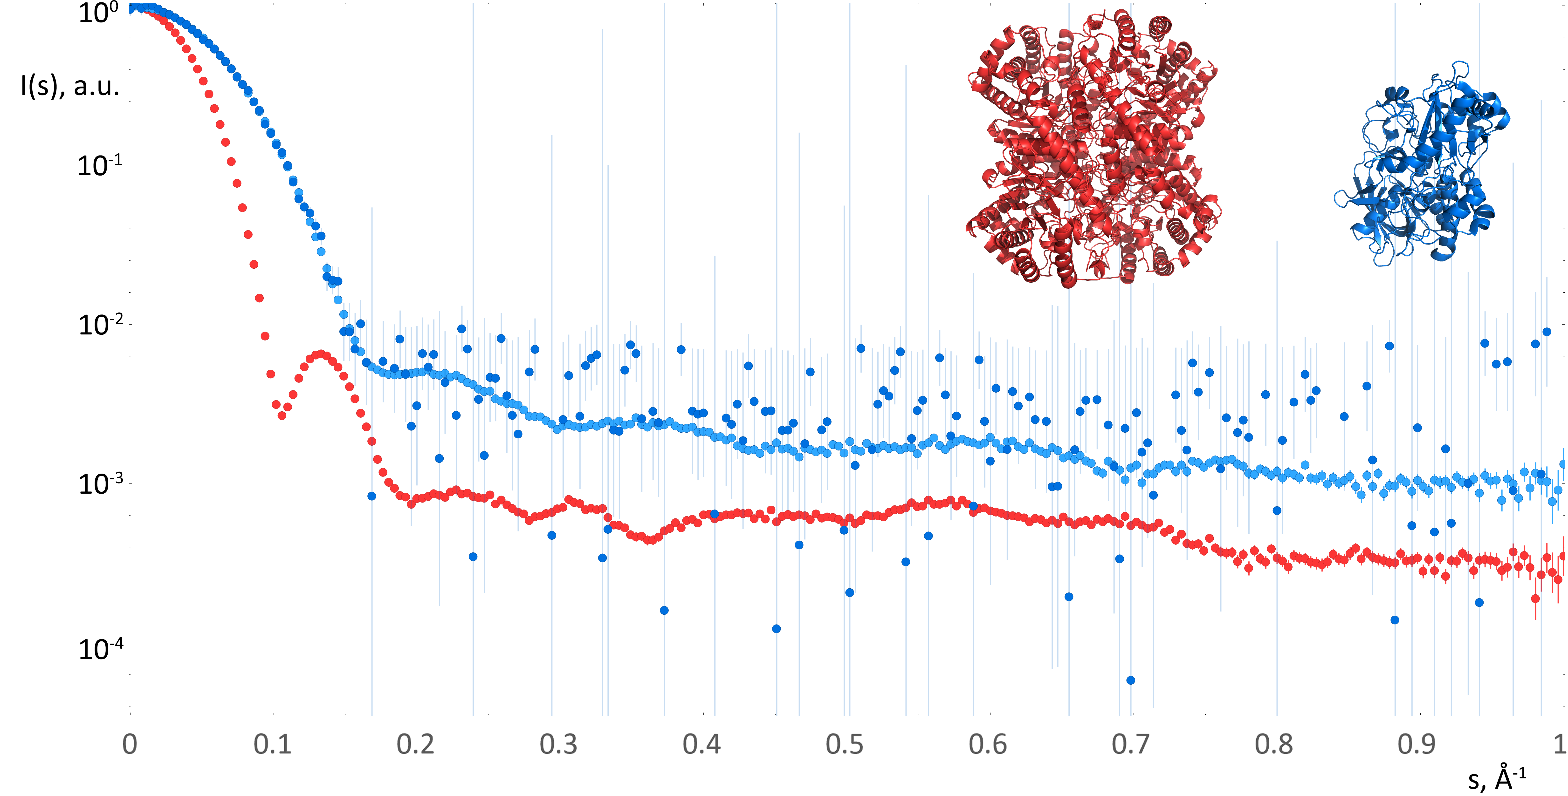

Figure 1. Examples of noise-augmented simulated data from the training set. Red dots: SAXS data computed from xylose isomerase (red model, pdb:1a0d, MW=198 kDa, Dmax=101.5 Å), concentration 16 mg/ml. Blue dots: data computed from oxidoreductase (blue model, pdb: 3b3r, MW=55.7 kDa, Dmax=79.1 Å), light blue dots correspond to the concentration 16 mg/ml, dark blue dots correspond to 0.5 mg/ml.

Neural networks architecture. A feedforward neural network consists of “dense” layers of interconnected units, each unit of each layer is connected to all units of the next layer (Figure 2). A unit essentially performs a multiple linear regression operation, then applies some activation function, and passes the result further to the next layer. Given an input vector $\vec{X}$, the unit does a dot multiplication of that vector with an internally stored vector of “weights” of the same dimensionality and (optionally) adds a scalar value:

, (10)

where w is the array of weights associated with the unit, b is the scalar (“bias”), and f is an analytical activation function. In this study we considered two activation functions: “rectified linear unit” (ReLU) and hyperbolic tangent (tanh).

A neural network contains an input layer, an output layer and one or more hidden layers (Figure 2). Here, the number of the units of the input layer corresponds to the number of I(s) points in the training set data (in this study the experimental uncertainties were not used for training). Since we expect the NN models to predict either MW or *Dmax*, the output layer consists of a single unit. The minimization algorithm optimizes the weights and biases of all units such that the output layer value becomes as close as possible to the “ground truth” values associated with the input data. This discrepancy is measured by a loss function; in this study we used the mean absolute percentage error. Once trained, the NN can be used for predicting the desired parameters from previously unseen input data.

To avoid overfitting – when a NN learns the training set too well and tries to fit specific, non-general features of the training set – a separate validation data set is prepared. During training the performance of NN is evaluated by applying the loss function to the validation set. Each simulated data set was randomly split into 80% training set and 10 % validation set. The remaining 10% (test set) were used to benchmark the results against other methods.

To find the optimal architecture, we tried different numbers of units and hidden layers to accurately predict MW and *Dmax.* The minimal architecture for MW prediction was just one hidden layer with five units whereas for Dmax prediction three layers with up to 80 units were necessary.

Various preprocessing normalizations were tested for input I(s) data and output MW or Dmax values. A simple I(0)=1 was found optimal for MW determination; additional subtraction of the mean training set SAXS profile improved the results for Dmax. In both cases the output values were normalized by the maximum.

Initially, six NNs were trained (three types of biological macromolecules, for MW and for Dmax) on the angular range up to 1.0 Å-1 using smooth data. The accuracy and robustness of MW/Dmax predictions were investigated by re-training the NNs using noisy data and different angular ranges.

In this work, we used the Tensorflow software library with Keras interface [https://www.tensorflow.org/about/bib] in Python. For benchmarking NNs against other methods we used the DATMW from ATSAS 3.0.3 (Manalastas-Cantos et al., 2021).

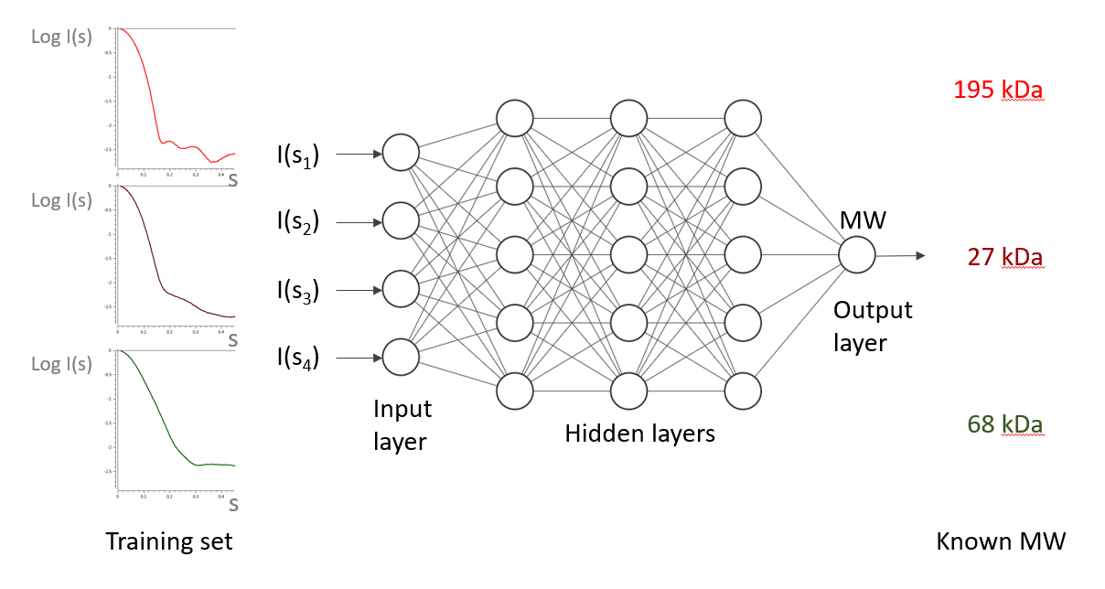

80 units

1 unit

256 units

Figure 2. Architecture of the neural networks trained for MW/Dmax estimation

## Application to experimental data

To prepare the input data for the format of the NNs, the further steps are required:

1. estimate I(0) from the Guinier approximation using AUTORG (Petoukhov, 2007);
2. normalize the data to I(0) = 1;
3. convert to Å-1 if necessary; rebin to the grid of the training set.

The angular range of the input SAXS data must match the range used for NN training. The sample type (folded protein/IDP/nucleic acid) must match the applied NN type.



# Results and discussion

To evaluate the performance on the simulated test set data and experimental data from SASBDB [Ref.] we used the average relative error as a metric of the prediction accuracy:

$〈∆_{rel}〉=\frac{1}{N}\sum_{i}{\frac{\left|P_{i}-{GT}_{i}\right|}{{GT}_{i}}}$, (11)

where *N* is the total number of models in the test set, *P* is the predicted value (either MW or Dmax) and *GT* is the ground truth value. In addition to the average, we computed the median relative error to control for the skewness of the error distribution.

For NNs trained on smooth (i.e. without added noise) data up to smax = 1.0 Å-1 and applied to the smooth test sets, we obtained the results presented in Table 1. For folded protein data the plots of the predicted values vs. ground truth values are shown in Figure 3.

|  |  |  |  |  |
| --- | --- | --- | --- | --- |
|  | MW average | MW median | Dmax average | Dmax median |
| Folded proteins | 2.50% | 1.87% | 2.78% | 2.13% |
| IDPs | 3.94% | 2.37% | 8.52% | 4.15% |
| Nucleic acids | 2.86% | 2.00% | 2.82% | 1.89% |

Table 1. Performance of the neural networks trained on smooth data and applied on smooth test sets: average and median relative errors.

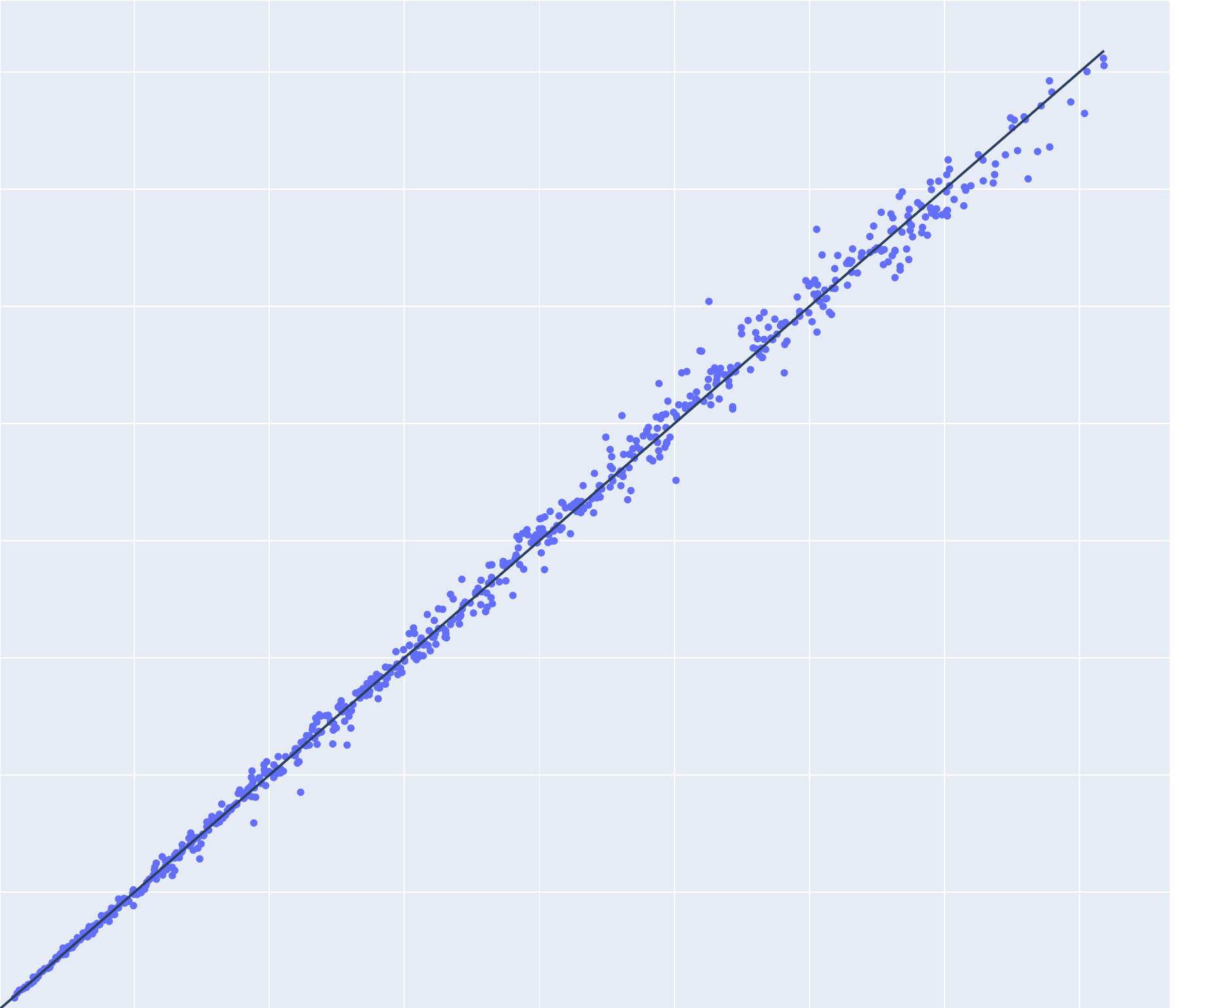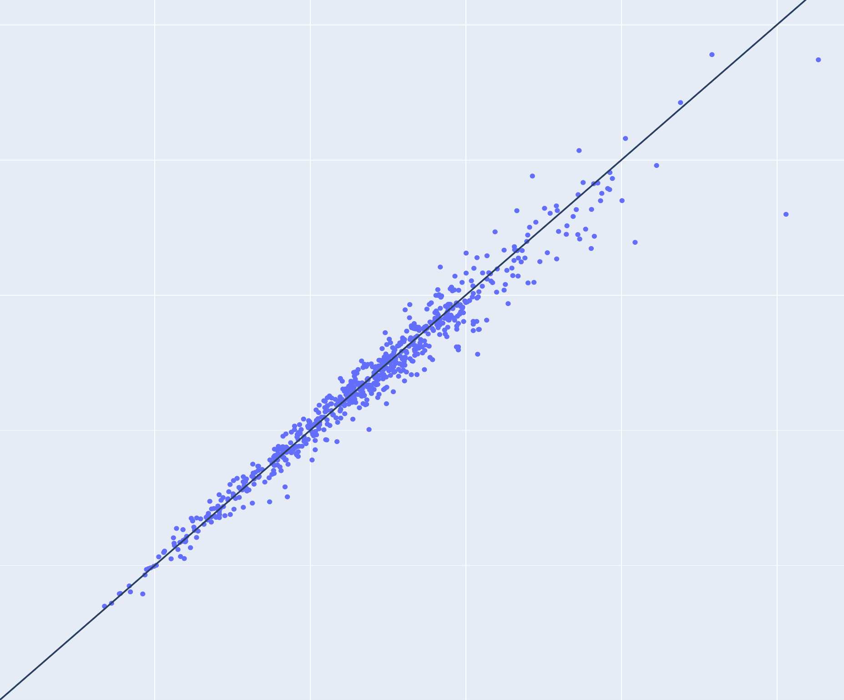

Predicted MW, kDa

Ground truth MW, kDa

Ground truth Dmax, Å

Predicted Dmax, Å

100

200

300

400

100

200

300

400

100

200

200

100

Figure 3. Predictions from 684 test data sets simulated from folded protein models (without added noise) versus ground truth. Left: molecular weight (MW), right: maximum intra-particle distance (Dmax). Lines of equality are in black.

Angular range. An important question arises: given the maximum angle *smax*, what is the maximum precision of MW and *Dmax* predictions that one can expect? The usage of NNs enables a convenient opportunity to get a deeper insight into the information content of different angular ranges of SAXS profiles. To evaluate the impact of the angular range on the accuracy of the MW and Dmax predictions, we re-trained the same NNs on smooth data computed from the folded proteins up to various smax: 0.8, 0.6, 0.4, 0.3, 0.2, 0.1, 0.05, 0.025 Å-1.

For the data cropped at smax=0.1 Å-1, the accuracy of Dmax predictions was 3.3%; it improves up to 2.8% with the angular range increased up to smax=0.4 Å-1 (see Figure 4, purple circles), further increase of the angular range did not affect the accuracy of the Dmax predictions. That illustrates the fact, that lower angles in reciprocal space contain information on the larger distances in real space.

­­­­­­­

Figure 4. Relative average MW error (green) and Dmax error (purple) estimated from smooth data decreases with increasing angular range. The light blue and red SAXS profiles (computed from the same models as in fig.1) are shown for demonstrative purposes only.

For MW prediction the impact of higher angles was more pronounced: the accuracy improves from 8% to 2.8% with smax increasing from 0.1 Å-1 to 0.6 Å-1 (see Figure 4, green circles). The intensities in this angular range mostly contain information on the molecule surface and inner structure, which indeed may contribute to the overall estimation of the MW.

Effects of the experimental noise. Depending on the sample concentration, contrast, molecule volume, intensity of the X-ray beam, the amount of the I(s) noise may vary drastically. To evaluate how the amount of noise impacts the prediction accuracy, we have added simulated noise to the folded proteins test data set (with known ground truth MW and Dmax) and first applied the above-mentioned NNs trained on the smooth data up to smax = 1.0 Å-1.

For simulated concentrations 4, 8 and 16 mg/ml the average relative MW error was below 3% (which was comparable to the MW accuracy of the smooth data set), but for the lower concentrations, the accuracy decreased significantly, see Figure 5 (blue circles). For the lowest concentrations (0.5 and 0.25 mg/ml) about 2% of the predictions were negative or very close to zero, i.e. the NN failed to produce an MW estimate; without these outliers, the average relative errors were 9.5% (0.5 mg/ml) and 18% (0.25 mg/ml).

Surprisingly, the NN trained to predict Dmax on noise-free data produced almost random outputs when applied to data with noise. Even for the 16 mg/ml test data, the number of negative predictions was 17% and the rest had an average relative Dmax error of 15%. For the lower concentrations, the predictions were practically uncorrelated with the ground truth values.

We have re-trained both NNs using the noise-augmented training set. This led to a significant improvement of the MW predictions on the lower concentrations c < 4 mg/ml (see Figure 5, orange circles) and there were no negative output values (failures). For simulated concentrations ≥ 1 mg/ml, the accuracy of prediction was below 3%. The Dmax predictions became reliable as well with less than 1% failures and average errors below 3.3% for the concentrations higher than 1 mg/ml; at 0.25 mg/ml the average error was 5.8% (which was comparable to the performance of the MW NN) and 2% failures.

Figure 5. Performance of neural networks trained to predict molecular weight on smooth data (blue circles) and trained on noise-augmented data (orange circles) applied to the noise-augmented test set.

Similarly, we trained the NNs on noise-augmented data simulated from IDPs and nucleic acids. To benchmark our results, we applied the NNs and the conventional methods implemented in ATSAS 3.0 [Ref] to the noise-augmented test sets. The all-to-all comparison is presented in Figure 6, where it is seen that the NNs not only outperform the conventional methods for all types of particles but are also more robust against simulated noise: the accuracy of predictions by NNs for both MW and *Dmax* improves gradually with the simulated concentration and reaches a plateau at concentrations above 1 mg/ml.

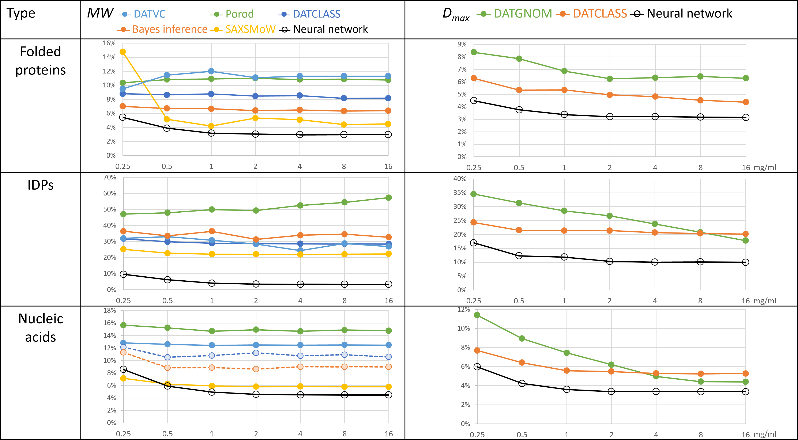

Figure 6. Average relative errors of the molecular weight (MW, left) and maximum intra-particle distance (Dmax, right) predictions for folded proteins (top), intrinsically disordered proteins (IDPs, middle) and nucleic acids (RNA and DNA, bottom) vs. simulated concentration. Comparison of conventional methods (colored circles/lines) with the NNs predictions (black circles/lines). Dashed lines represent methods not directly applicable for estimating MW from nucleic acids data.

­­­­­­

IDPs happened to be the most challenging objects for predictions. The conventional methods failed to produce reasonable MW estimates with the <Δrel> in the range of 20%–50%, while the NN showed much better results of 3-10% enabling to reliably estimate the MW of IDPs from SAXS data.

The conventional methods for MW estimation were developed for proteins and are not directly applicable to data from nucleic acids. In the case of Vc method, we have used the empirically determined coefficients (eq.7) reported by [Rambo&Tainer]. Based on our training set, we have applied corrections on MW estimation for nucleic acids for Porod’s method and SAXSMoW.

Experimental data.

To evaluate the performance of our approach on real experimental data, we needed SAXS data collected from well-characterized monodisperse solutions with reliably determined MW and Dmax “ground truth” values. For folded proteins, we used data from 29 SASBDB [ref] entries that were tagged “Benchmark” and, with some exceptions, fitted by atomic models. The “ground truth” MW values were calculated from the protein sequence, the “ground truth” Dmax values were obtained from the models. The neural networks were retrained using the same training set but on the least common experimental data angular range 0.02 < s < 0.3 Å-1.

The average relative MW and Dmax errors were 10% and 7%. We have inspected the cases where the predictions were most inaccurate. In the case of apoferritin, the MW was underestimated by 22% which was expected because the MW of apoferritin (479 kDa) is beyond the range of the training set (up to 410 kDa). In the case of ribonuclease (16.5 kDa) the MW was underestimated by 30% and Dmax was overestimated by 11% – possibly because 17% of the protein is flexible and not present in the model (PDB: 3MZQ). The detailed results are summarized in Supplementary Table s1.

To study the reproducibility of MW and Dmax predictions from experimental data, we used 100 background-subtracted data sets from SASDDN3 [ref machine learning]. The data were collected at the EMBL P12 beam line [ref] from 2.25 mg/ml solution of bovine serum albumin, exposure time 50 ms. For MW the obtained average prediction was 73.8 kDa, standard deviation 2.3 kDa, for Dmax the average was 108 Å and the standard deviation 4 Å.

### Current limitations and perspectives

The presented approach works only for macromolecules within the MW/Dmax ranges covered by the training sets. The predicted values might be negative if the NN failed to make a reasonable prediction e.g. if the input data are too different from the training set. One could expand the applicability of the trained NNs by scaling the input data angular range and adjust the predicted parameters accordingly.

To expand the applicability, one could enlarge the training set. In this study, we have used only experimentally determined models of proteins and nucleic acids. It is possible to further enhance the folded proteins training set by using models computed by Alpha-Fold [ref.] or other structure prediction approaches; the IDPs training set is amendable by RANCH [ref. EOM 2.0]. The extension of the nucleic acids training set is possible by using software for secondary (e.g. Mfold (research and 2003)) and tertiary structure (e.g. OligoAnalyzer (Owczarzy et al.)) predictions.

To estimate the confidence intervals of the predicted values, one could apply an ensemble of independently trained NNs or snapshots of a single neural network, converging to several local minima along its optimization path [arXiv:1704.00109]. Alternatively, one could determine the variability of the predicted values by resampling of the input data (i.e. adding pseudo experimental noise) using DATRESAMPLE [ref to ATSAS 2020].

To further expand the applicability of NNs to experimental data, one could augment the training set by simulating the structure factor, adding systematic noise, simulating polydispersity.

# Conclusions

We presented a novel method for the estimation of primary SAXS parameters using neural networks. The comparison of our method with existing methods applied on folded proteins data demonstrated higher accuracy and robustness against noise. Due to the fact, that our method is not confined within the frames of any approximations (e.g. the homogeneity of electron density), it allows us to anew assess the real capacities of SAXS data in terms of information content and to push further the accuracy of SAXS primary data analysis beyond the commonly accepted uncertainty of 10%.

To the best of our knowledge, our method is a conceptually new approach to reliably estimate the molecular weight from intrinsically disordered proteins and nucleic acids SAXS data. The *Dmax* estimations by our method do not require IFT and can be done directly from experimental data. The developed methods for MW and *Dmax* estimation will be included in the next ATSAS release, free for academic use.

# Acknowledgments

The work was supported by the BMBF grant 16QK10A (SAXS-BSOFT).

# References

Armenteros, J.J.A., Salvatore, M., Emanuelsson, O., Winther, O., Von Heijne, G., Elofsson, A., and Nielsen, H. (2019). Detecting sequence signals in targeting peptides using deep learning. Life Sci. Alliance *2*.

Barberato, C., Henri, M., Koch, J., Svergun, D., Barberato, C., and Koch, M.H.J. (1995). CRYSOL-a Program to Evaluate X-ray Solution Scattering of Biological Macromolecules from Atomic Coordinates Projet View project Projet4 View project CRYSOL-a Program to Evaluate X-ray Solution Scattering of Biological Macromolecules from Atomic Coordinates. Artic. J. Appl. Crystallogr. *28*, 768–773.

Berman, H., Westbrook, J., … Z.F.-N. acids, and 2000, undefined The protein data bank. Academic.Oup.Com.

Berman, H.M., Westbrook, J., Feng, Z., Gilliland, G., Bhat, T.N., Weissig, H., Shindyalov, I.N., and Bourne, P.E. (2000). The Protein Data Bank. Nucleic Acids Res. *28*, 235–242.

Bertero, M., De Mol, C., and Viano, G.A. (1980). The Stability of Inverse Problems. In Dokl. Akad. Nauk SSSR, pp. 161–214.

Blanchet, C., Spilotros, A., … F.S.-J. of applied, and 2015, undefined Versatile sample environments and automation for biological solution X-ray scattering experiments at the P12 beamline (PETRA III, DESY). Scripts.Iucr.Org.

Chiti, F., and Dobson, C.M. (2006). Protein misfolding, functional amyloid, and human disease. Annu. Rev. Biochem. *75*, 333–366.

Coimbatore Narayanan, B., Westbrook, J., Ghosh, S., Petrov, A.I., Sweeney, B., Zirbel, C.L., Leontis, N.B., and Berman, H.M. (2014). The Nucleic Acid Database: new features and capabilities. Nucleic Acids Res. *42*, D114–D122.

crystallography, P.M.-J. of applied, and 1980, undefined Small-angle scattering. Information content and error analysis. Scripts.Iucr.Org.

Cybenko, G. (1989). Approximation by superpositions of a sigmoidal function. Math. Control. Signals, Syst. *2*, 303–314.

Debye, P. (1915). Zerstreuung von Röntgenstrahlen. Ann. Phys. *351*, 809–823.

Feigin, L.A., Svergun, D.I., and Taylor, G.W. (1987). Principles of the Theory of X-Ray and Neutron Scattering. In Structure Analysis by Small-Angle X-Ray and Neutron Scattering, (Springer US), pp. 3–24.

Fischer, H., De Oliveira Neto, M., Napolitano, H.B., Polikarpov, I., and Craievich, A.F. (2010). Determination of the molecular weight of proteins in solution from a single small-angle X-ray scattering measurement on a relative scale. J. Appl. Crystallogr. *43*, 101–109.

Franke, D., Jeffries, C.M., and Svergun, D.I. (2018). Machine Learning Methods for X-Ray Scattering Data Analysis from Biomacromolecular Solutions. Biophys. J. *114*, 2485–2492.

Fukuchi, S., Hosoda, K., Homma, K., Gojobori, T., and Nishikawa, K. (2011). Binary classification of protein molecules into intrinsically disordered and ordered segments. BMC Struct. Biol. *11*.

Glatter, O. (1977). Data evaluation in small angle scattering: calculation of the radial electron density distribution by means of indirect Fourier transformation. Acta Phys. Austriaca *47*, 83–102.

Gräwert, T.W., and Svergun, D.I. (2020). Structural Modeling Using Solution Small-Angle X-ray Scattering (SAXS). J. Mol. Biol. *432*, 3078–3092.

Guinier, A., and Fournet, G. (1955). Small-angle scattering of X-rays (Translation by C. B. Walker).

Hajizadeh, N.R., Franke, D., Jeffries, C.M., and Svergun, D.I. (2018). Consensus Bayesian assessment of protein molecular mass from solution X-ray scattering data. Sci. Rep. *8*, 1–13.

Hanin, B. (2019). Universal function approximation by deep neural nets with bounded width and ReLU activations. Mathematics *7*, 1–9.

He, H., Liu, C., and Liu, H. (2020). Model Reconstruction from Small-Angle X-Ray Scattering Data Using Deep Learning Methods. IScience *23*, 100906.

Hopkins, J.B., Gillilan, R.E., and Skou, S. (2017). BioXTAS RAW: Improvements to a free open-source program for small-angle X-ray scattering data reduction and analysis. J. Appl. Crystallogr. *50*, 1545–1553.

Kikhney, A.G., and Svergun, D.I. (2015). A practical guide to small angle X-ray scattering (SAXS) of flexible and intrinsically disordered proteins. FEBS Lett. *589*, 2570–2577.

Kikhney, A.G., Borges, C.R., Dmitry, |, Molodenskiy, S., Jeffries, C.M., and Svergun, D.I. (2019). SASBDB: Towards an automatically curated and validated repository for biological scattering data. Wiley Online Libr. *29*, 66–75.

Konarev, P. V, and Svergun, D.I. (2015). A posteriori determination of the useful data range for small-angle scattering experiments on dilute monodisperse systems. *2*, 352–360.

Lazar, T., Martínez-Pérez, E., … F.Q.-N. acids, and 2021, undefined PED in 2021: a major update of the protein ensemble database for intrinsically disordered proteins. Academic.Oup.Com.

Liu, H., Hexemer, A., and Zwart, P.H. (2012). The Small Angle Scattering ToolBox (SASTBX): An open-source software for biomolecular small-angle scattering. J. Appl. Crystallogr. *45*, 587–593.

Lu, Z., Pu, H., Wang, F., Hu, Z., and Wang, L. The Expressive Power of Neural Networks: A View from the Width.

Manalastas-Cantos, K., Konarev, P. V., Hajizadeh, N.R., Kikhney, A.G., Petoukhov, M. V., Molodenskiy, D.S., Panjkovich, A., Mertens, H.D.T., Gruzinov, A., Borges, C., et al. (2021). ATSAS 3.0 : expanded functionality and new tools for small-angle scattering data analysis . J. Appl. Crystallogr. *54*, 343–355.

McKay, M.D., Beckman, R.J., and Conover, W.J. (1979). A Comparison of Three Methods for Selecting Values of Input Variables in the Analysis of Output from a Computer Code. Technometrics *21*, 239.

Mylonas, E., and Svergun, D.I. (2007). Accuracy of molecular mass determination of proteins in solution by small-angle X-ray scattering. In Journal of Applied Crystallography, (International Union of Crystallography), pp. s245–s249.

Oldfield, C.J., and Dunker, A.K. (2014). Intrinsically Disordered Proteins and Intrinsically Disordered Protein Regions. Http://Dx.Doi.Org/10.1146/Annurev-Biochem-072711-164947 *83*, 553–584.

Owczarzy, R., Tataurov, A., … Y.W.-N. acids, and 2008, undefined IDT SciTools: a suite for analysis and design of nucleic acid oligomers. Academic.Oup.Com.

Petoukhov, M. V., Franke, D., Shkumatov, A. V., Tria, G., Kikhney, A.G., Gajda, M., Gorba, C., Mertens, H.D.T., Konarev, P. V., and Svergun, D.I. (2012). New developments in the ATSAS program package for small-angle scattering data analysis. J. Appl. Crystallogr. *45*, 342–350.

Rambo, R.P., and Tainer, J.A. (2013). Accurate assessment of mass, models and resolution by small-angle scattering. Nature *496*, 477–481.

research, M.Z.-N. acids, and 2003, undefined Mfold web server for nucleic acid folding and hybridization prediction. Academic.Oup.Com.

Schmidhuber, J. (2015). Deep Learning in neural networks: An overview. Neural Networks *61*, 85–117.

Senior, A.W., Evans, R., Jumper, J., Kirkpatrick, J., Sifre, L., Green, T., Qin, C., Zídek, A., Nelson, A.W.R., Bridgland, A., et al. AlphaFold: Improved protein structure prediction using 1 potentials from deep learning 2.

Svergun, D.I. (1992). Determination of the regularization parameter in indirect-transform methods using perceptual criteria. J. Appl. Cryst *25*, 495–503.

Uversky, V.N., and Dunker, A.K. (2010). Understanding protein non-folding. Biochim. Biophys. Acta - Proteins Proteomics *1804*, 1231–1264.

Uversky, V.N., Oldfield, C.J., and Dunker, A.K. (2008). Intrinsically disordered proteins in human diseases: Introducing the D 2 concept. Annu. Rev. Biophys. *37*, 215–246.

Vestergaard, B., and Hansen, S. (2006). Application of Bayesian analysis to indirect Fourier transformation in small-angle scattering. J. Appl. Crystallogr. *39*, 797–804.

Cell / structure:

A basic guideline in terms of the length for our Resource and Review articles is 8000-8500 words (including references and figure legends), and up to 7 display items (figures + tables). Further details can be found at: [https://www.cell.com/structure/article-types](https://www.cell.com/structure/article-types" \t "_blank). If needed, we are happy to provide feedback to our authors on outlines and drafts.

When you are ready, you may submit your manuscript to our [online submission system](https://www.editorialmanager.com/structure/default.aspx" \t "_blank). If you have any questions or concerns, please let me know and I’d be happy to assist you.